Gallery of beam simulation examples

The purpose of this gallery is to give the reader a general idea and understanding of the effects that various parameters have on the resulting acoustic beam.

1. About Continuous wave beams

Continious-wave (narrowband) beam simulation are an approximation of real life ultrasonic beams. In reality, short impulses (wideband) are more often used. However, continuous-wave beams are faster to simulate, thus easier to explore and understand. The general effect trends (beam width e.t.c.) are similar across narrowband and wideband operation.

1. Single radiating element – effect of the aperture size

In this simulation, a relationship between single element size and the acceptance angle is sought. A dense point grid is used to approximate the behaviour of a flat, single-element monopole (baffled) radiator.

The code that generates the following figures is cueBeam\_single\_element.m

**Effect:** The smaller the array element, the more omni-directional it is. The bigger the array element, the narrower the acceptance angle.

Cross-section view.

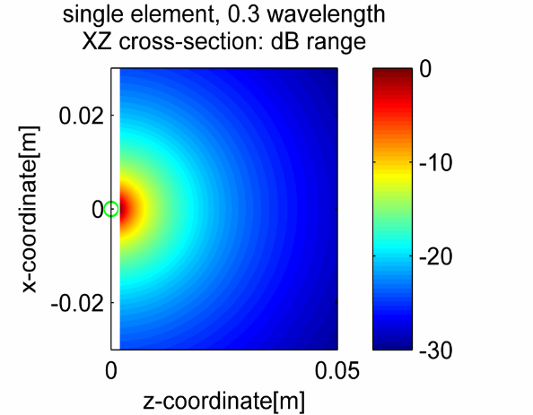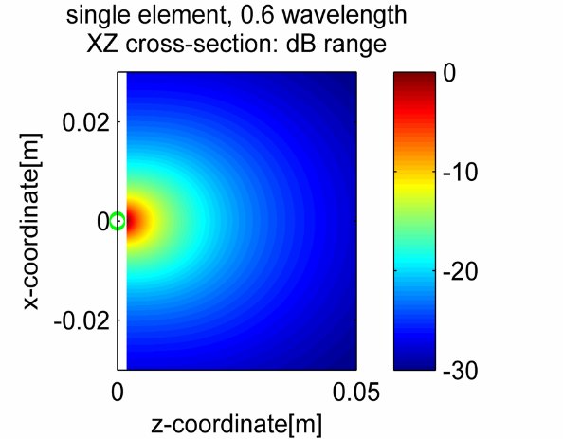

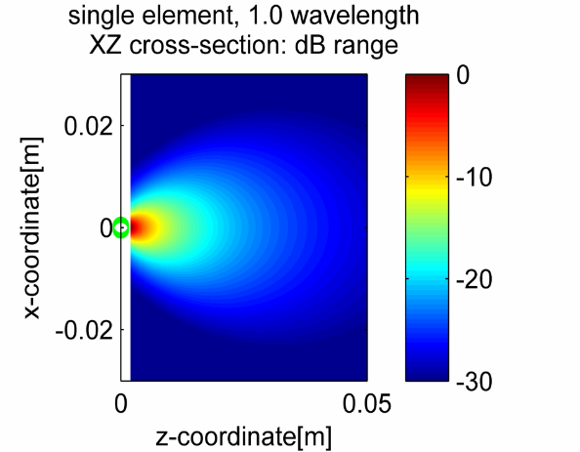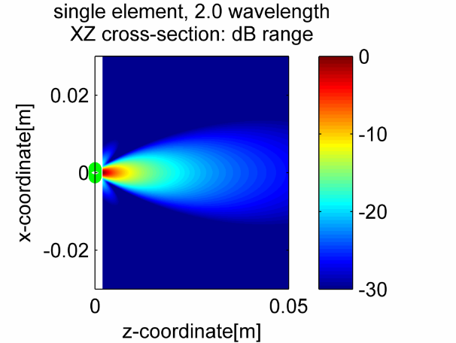

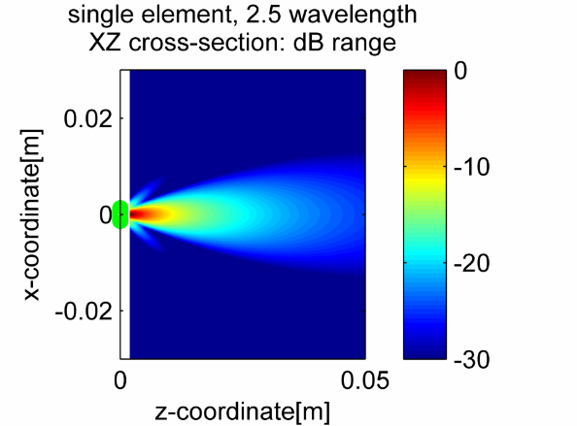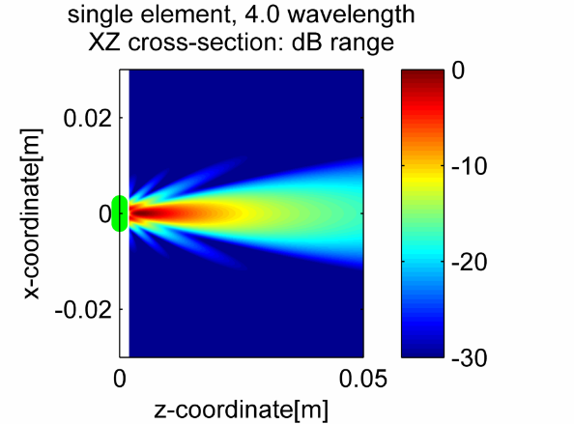

Perspective view:

|  |  |
| --- | --- |
| C:\Users\Jurek\AppData\Local\Microsoft\Windows\INetCache\Content.Word\element_0.6_perspective.png  0.6λ | C:\Users\Jurek\AppData\Local\Microsoft\Windows\INetCache\Content.Word\element_4.0_perspective.png  4.0λ |

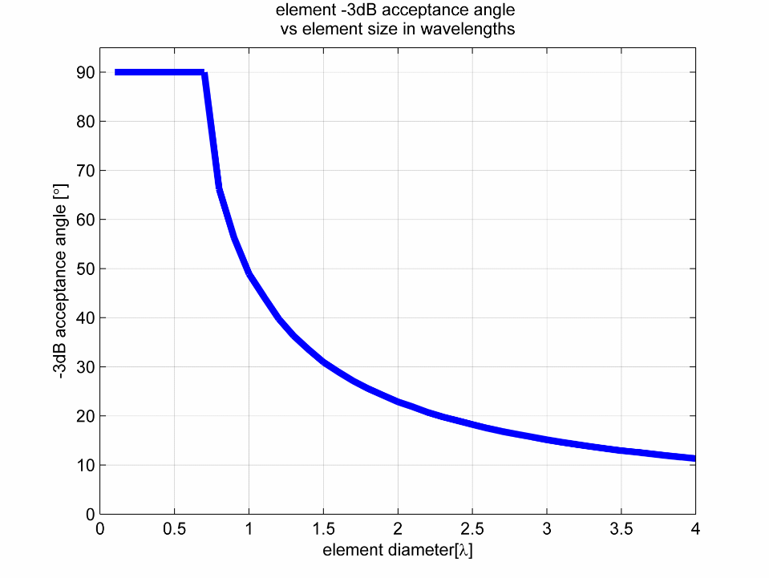

Figure. -3dB acceptance angle of a disk element vs its size in wavelengths. Note that this applies to single frequency (continuous) radiation only.

1. Linear array – effect of sampling density. Oversampled, λ/2 sampled, and Undersampled (sparse)

For a given array element count (here: 8), the wider the element spacing, the bigger the aperture, and consequently, the higher the focussing power of the probe (narrower main beam). However, since the total information content does not increase, the narrow focus is only obtained at the expense of contrast – high side lobe level; until eventually, grating lobes appear.

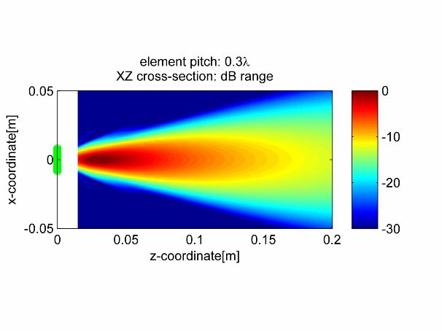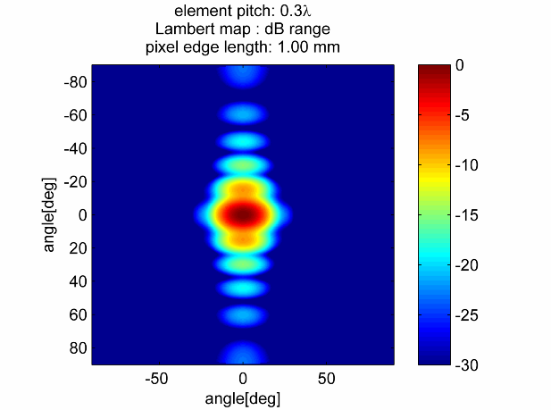

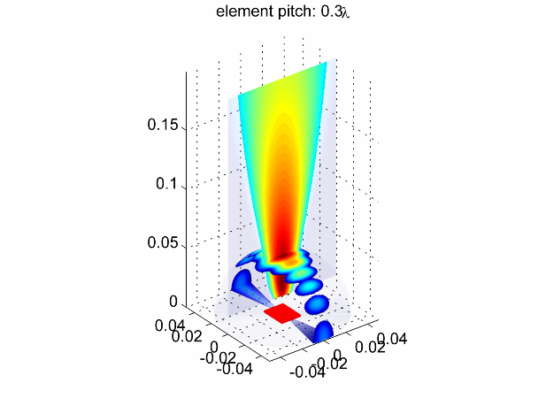

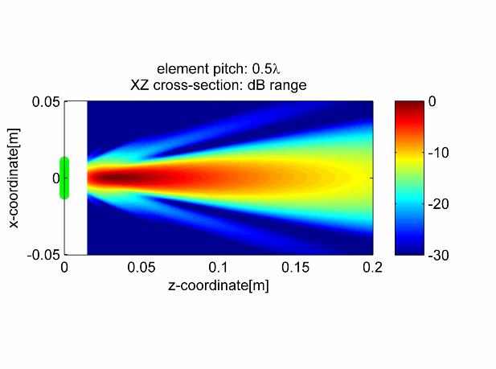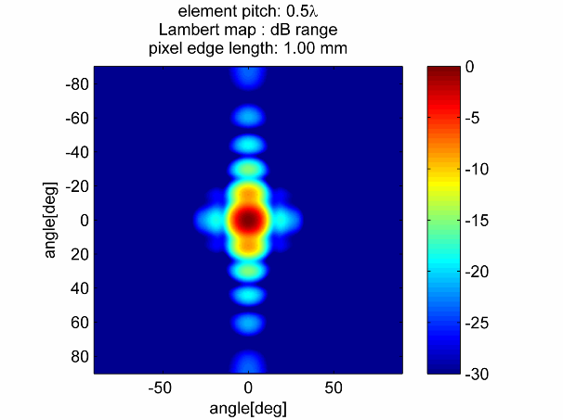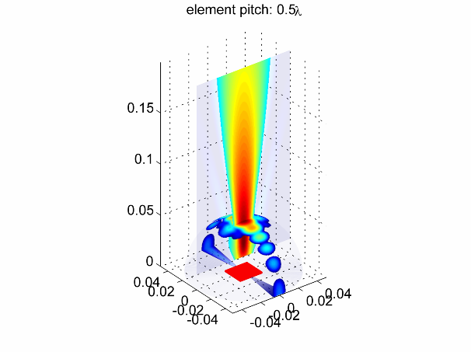

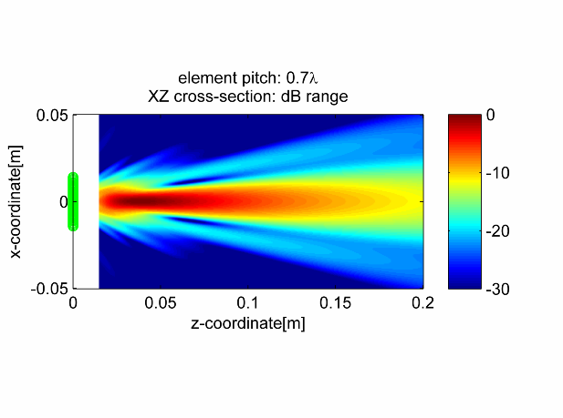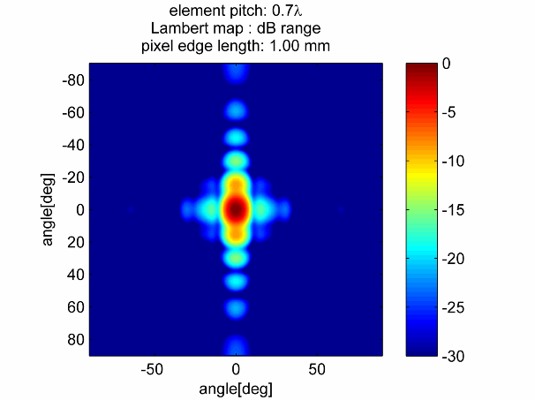

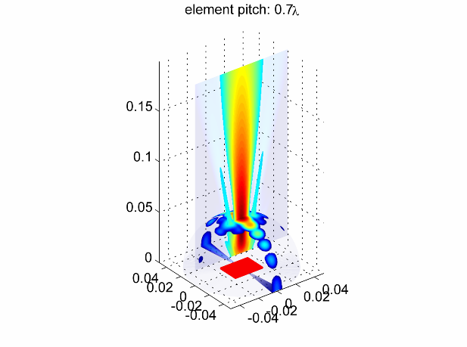

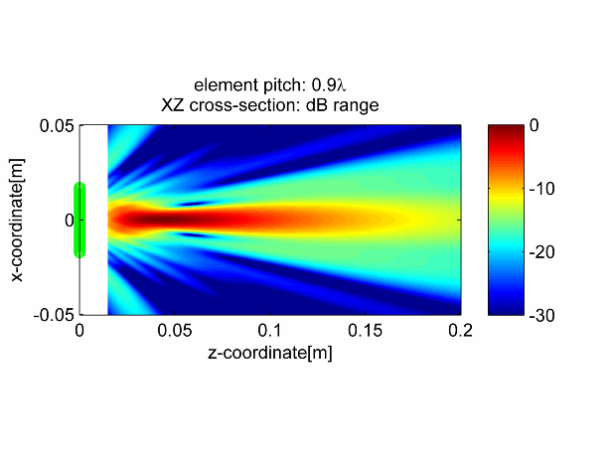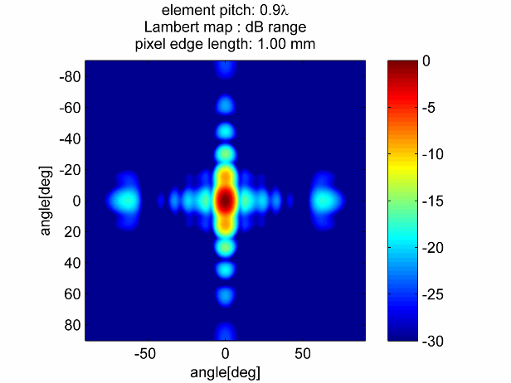

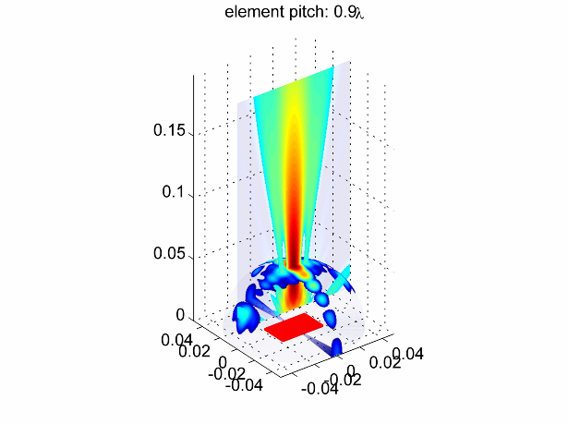

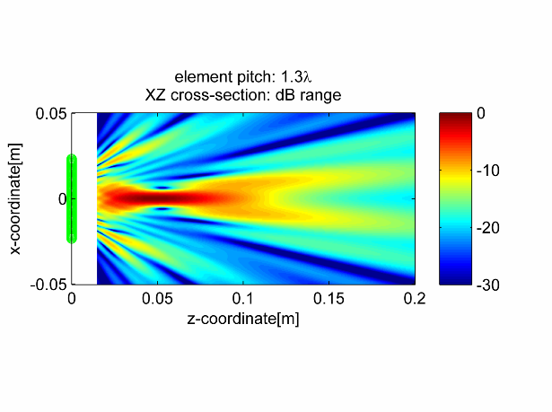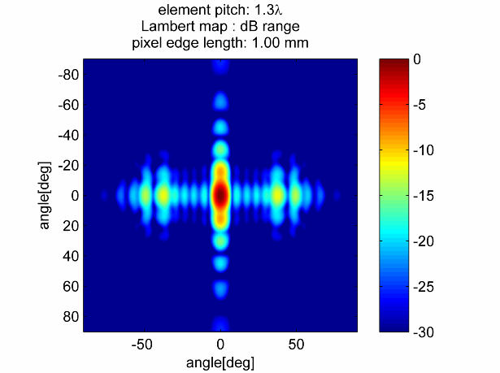

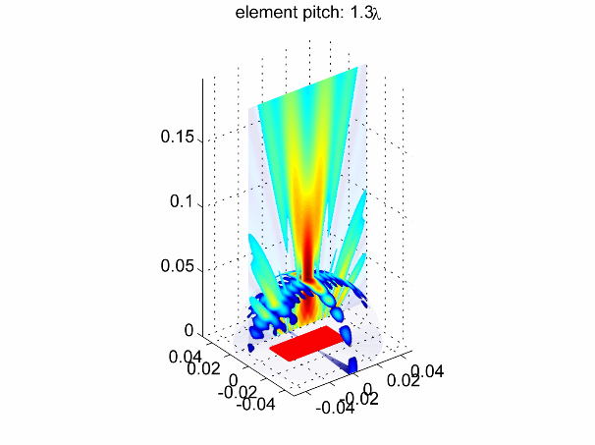

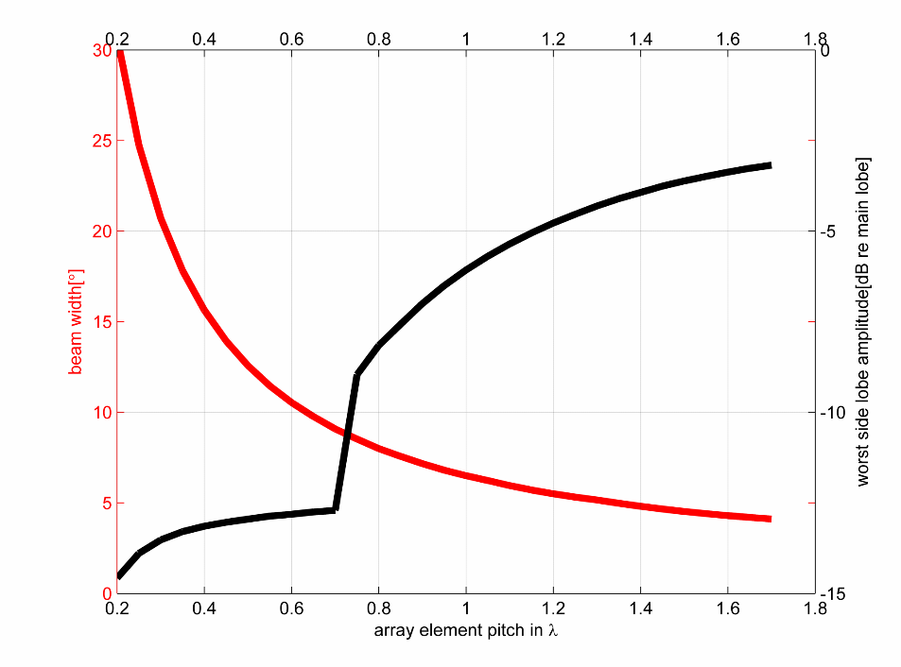

Beam width and side lobe amplitude vs array element pitch, 8-element array, no apodisation. Grating lobe appears beyond the pitch of λ/2.

1. Linear array – effect of element count.

The more active elements the array has, the more data can it acquire; this results in narrower main lobe, and lower side lobes at the same time. This comes at a higher cost of the completed probe.

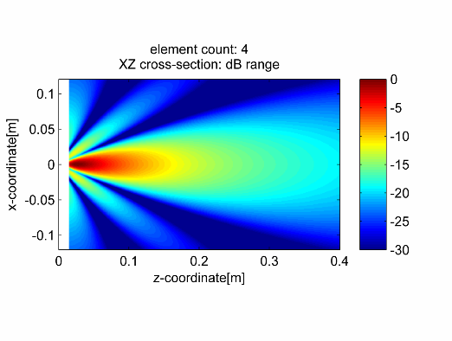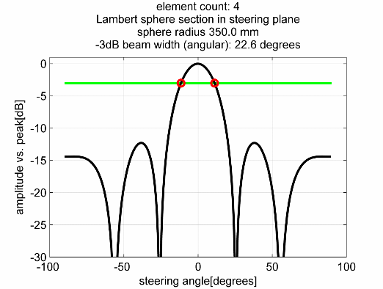

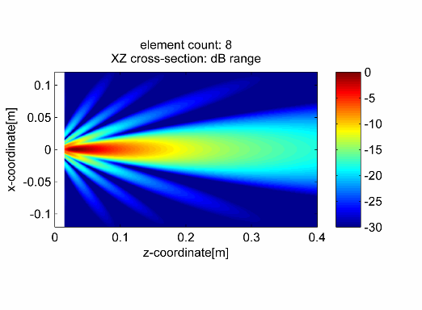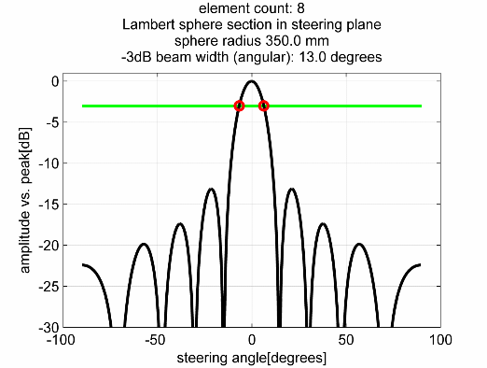

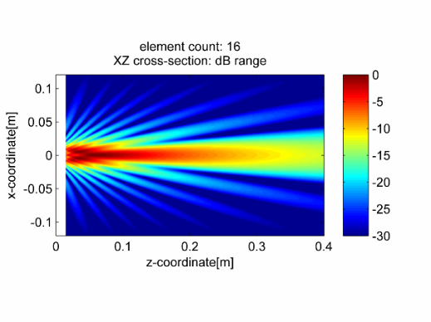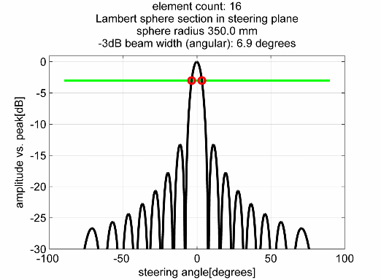

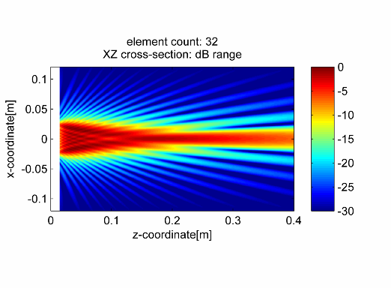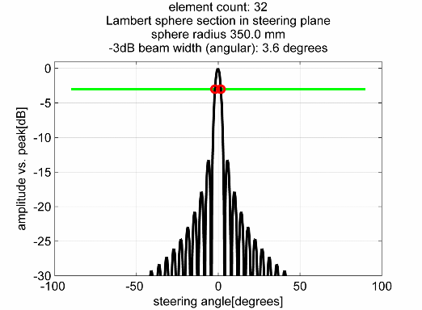

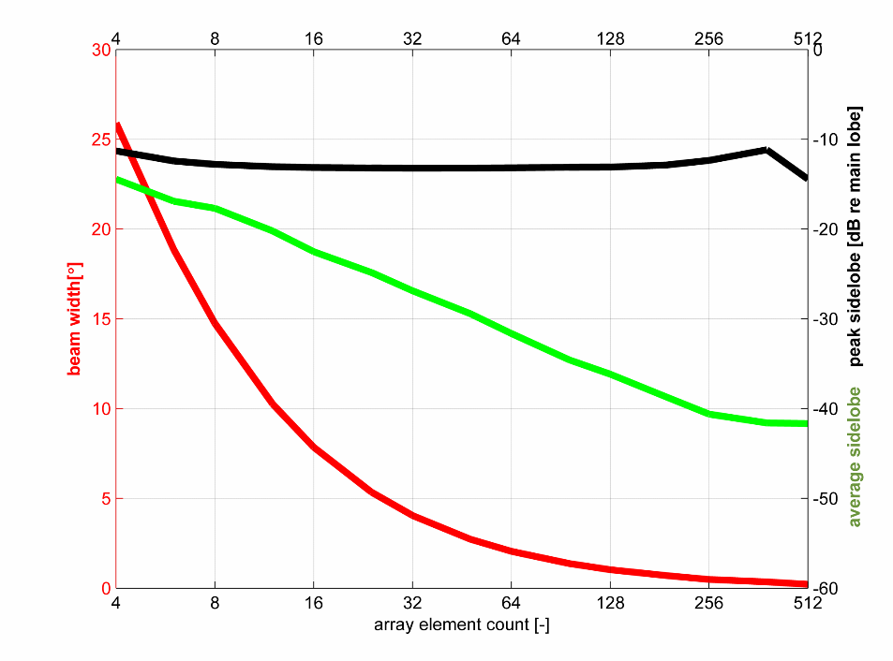

Beam width, worst (first) side lobe amplitude, and mean side lobe amplitude as a function of count of elements.

1. Linear array apodisation – rectangular, Hanning, Flat-Top

For NDE applications, typically no weighting is applied to the beamforming coefficients. This approach is also known under names of “no apodisation” “no windowing” or “rectangular window’ or “boxcar” windowing.

However, apodisation might be beneficial in some cases. Apodisation – also known as weighting, shadowing, or windowing, applies specific weights to the array signals. The effect most often sought is reducing the side lobe amplitude (improving contrast), which comes at the cost of wider main lobe.

Rectangular window uses maximum energy of all of the acquired signals yielding best main lobe SNR, and produces narrowest possible main lobe.

Hanning apodisation trades some of the main lobe width for reduced side lobes.

Flat top apodisation is optimised for lowest possible side lobe level, and uses partially negative weighting to reinforce the effect.

There is many other apodisation schemes, which are often optimal for their respective optimality criteria. Recent research explores complex (taking phase of the signal into account) apodisation weightings to further improve performance, and adaptive weightings that allow directing nulls of the beam into specific directions, i.e. those of known interfering signals.

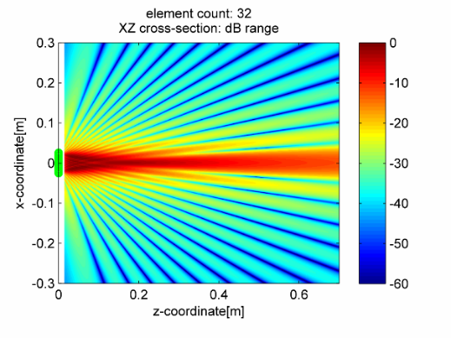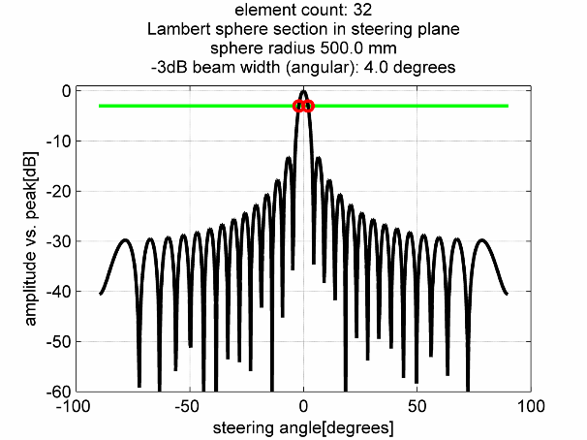

No apodisation (rectangular window)

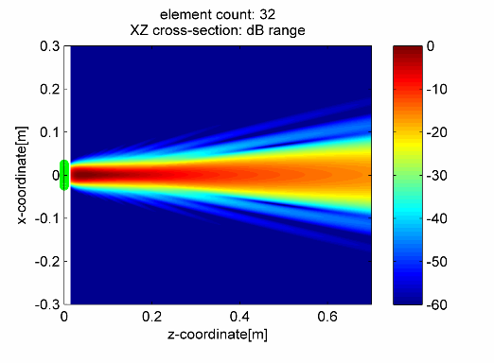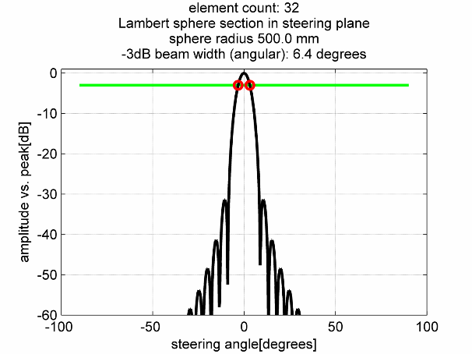

Hanning window

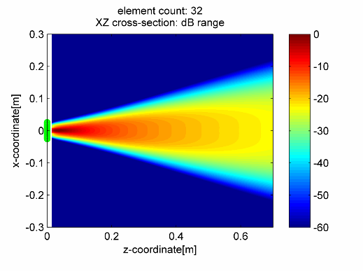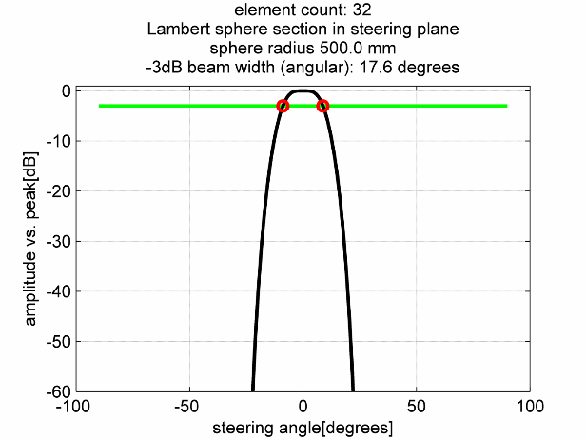

Flat top window

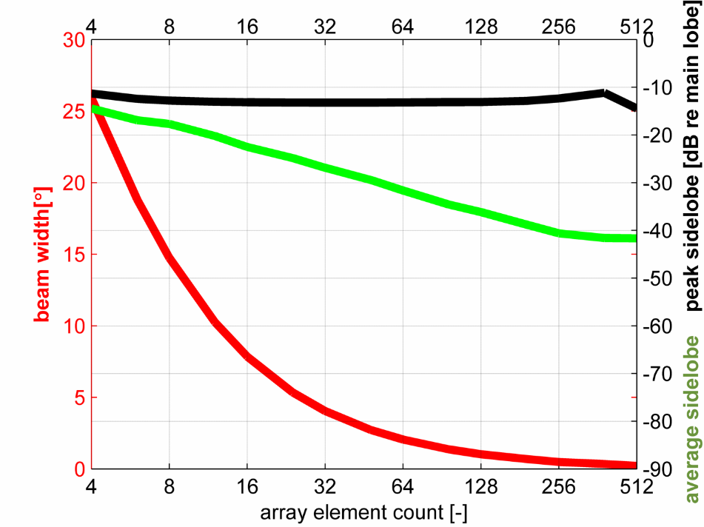

Rectangular (none) apodisation

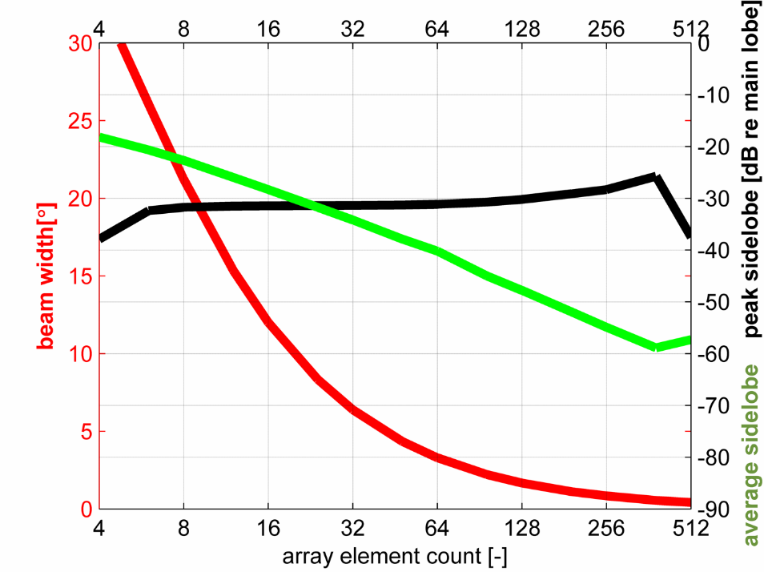

Hanning apodisation

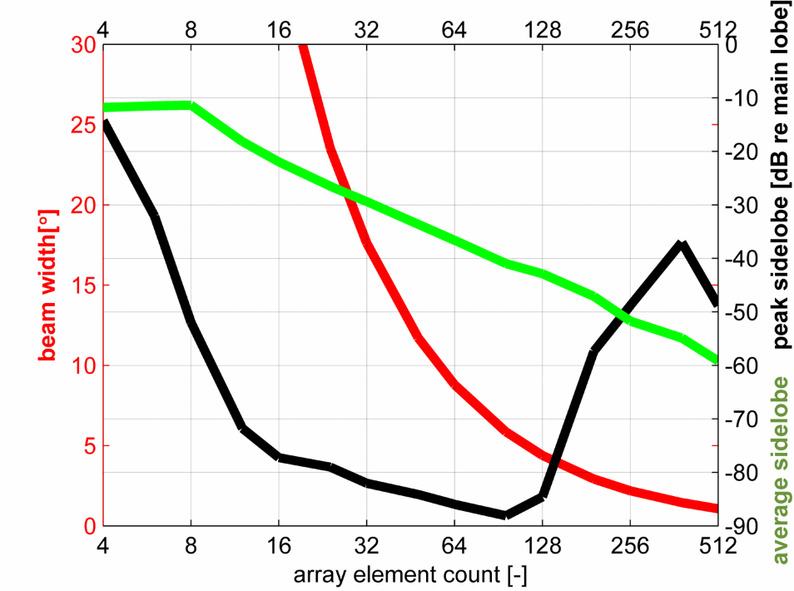

Flat top apodisation

1. Near-far field boundary – cross-section

“Near-field” is a volume near the surface of the probe where rapid spatial oscillations of the field amplitude occur. When no focussing laws are applied, for a probe of aperture diameter D radiating wavelength λ, the near-to-far field transition area produces ‘natural focus’ at ¼ of the Fraunhofer distance $d_{f}$:

$$d_{f}=\frac{2D^{2}}{4λ}$$

Examples: these series vary the element count, and thus, effective aperture of the radiator. The Fraunhofer transition occurs at consecutively bigger distances.

The figure on the right represents a cross-section through the middle of the figure on the left.

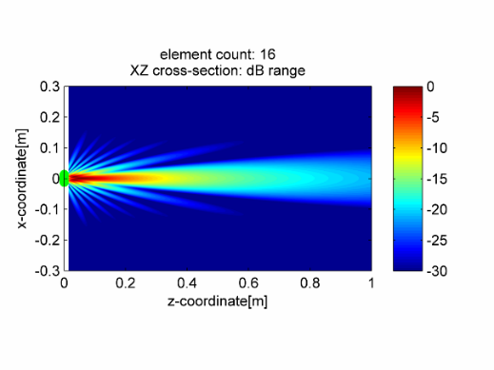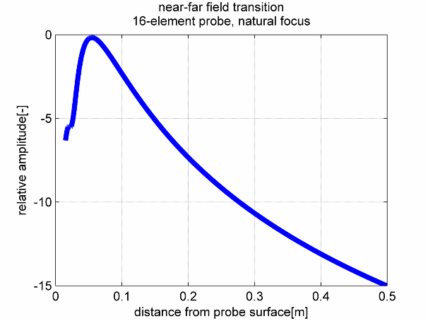

16 elements, natural focus distance 43.1mm

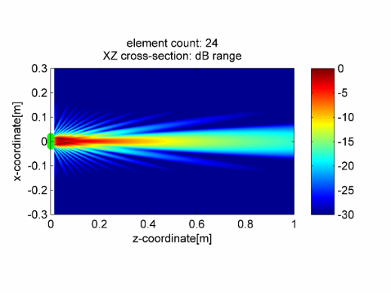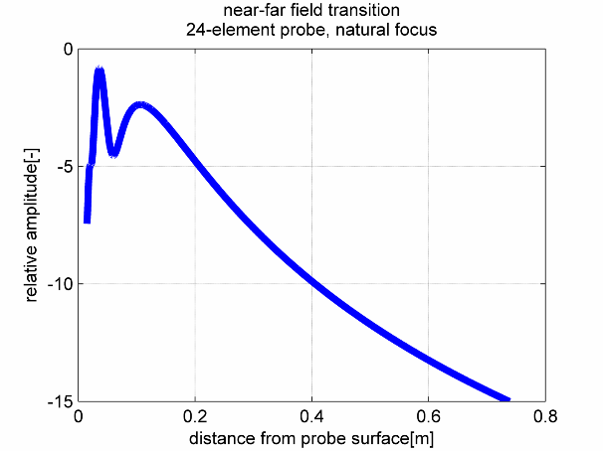

24 elements, natural focus distance 97.0mm

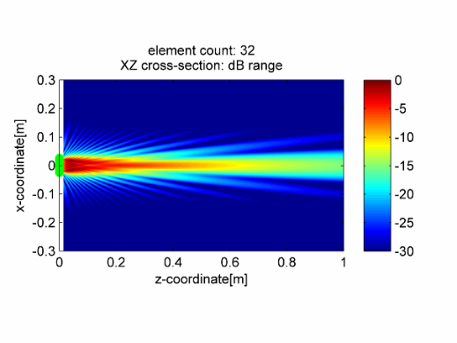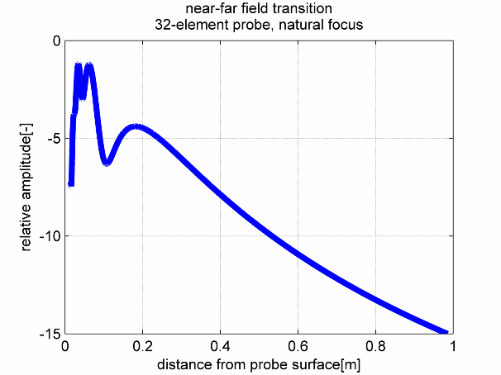

32 elements, natural focus distance 172.5mm

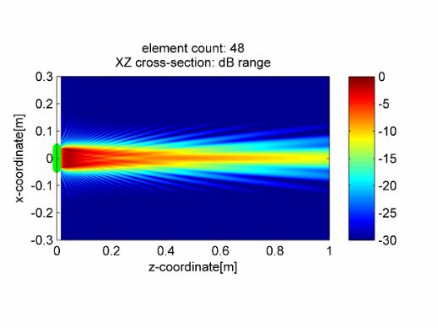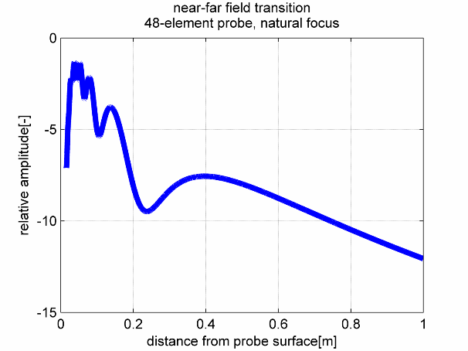

48 elements, natural focus distance: 388mm

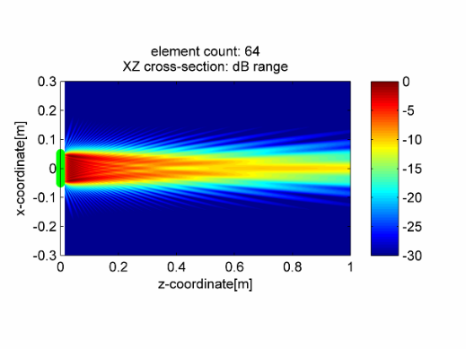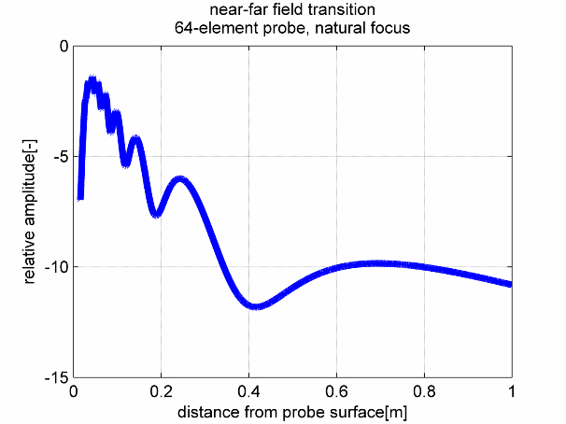

64 elements, natural focus distance: 689.9mm

1. Depth Focussing

Focussing is only effective inside the near field region. Attempting to focus beyond the $d_{f}$ distance produces a result that is virtually the same as ‘focus at infinity’. For the 32 element probe in the examples below, $d_{f}=172.5mm$

